Scott Scheraga

Graduate Project Report: Police Academy Turret Pitch and Rotation Mechanisms

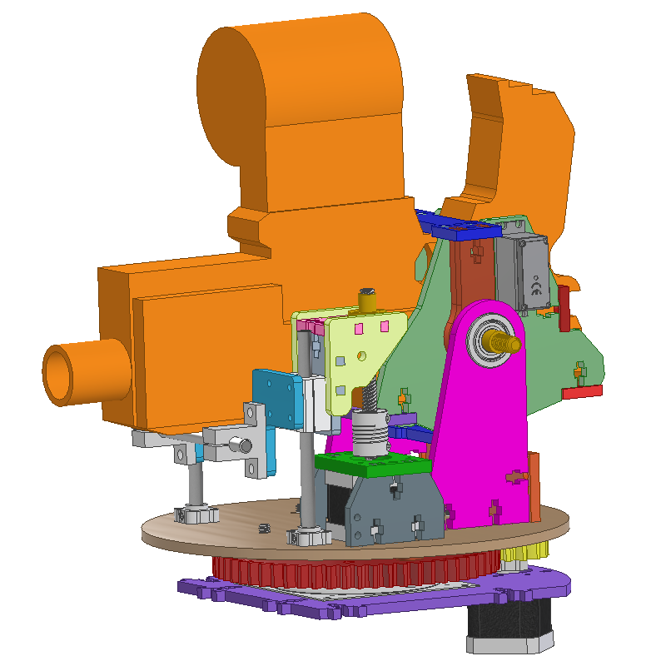MCEN 5115: Mechatronics and Robotics I

4/30/2020

My graduate project, as permitted by Professor Reamon, was the Nerf Gun Turret Pitch and Rotation Subsystems for my team’s Police Academy Robot semester project. This graduate project was likely deemed to be reasonable due to my turret system being above-and-beyond the scope of the original guidelines for the semester project. General expectations for robot turret systems were likely a Nerf gun or BB-gun firing mechanism rigidly fixed to a mobile robot platform with sensors/cameras for navigation and a camera for target acquisition. Once a target would have been acquired within camera frame, aiming procedure for the gun would be performed by rotating the robot to account for horizontal offset, and driving the robot towards or away from the target in order to account for vertical offset.

I managed to convince my team to allow me to devote a significant amount of time towards developing these subsystems, for the following reasons. 1: Potentially easier aiming, as the team would not theoretically need as much time to “dial in” my turret subsystem, compared to dialing in robot rotation and forward/back pitching motion to aim at different distances. 2: Potentially easier navigation of the course, as we would not need to adjust robot position every time the robot aims at a target, causing possible issues re-localizing the robot within the course. 3: Potentially wider targeting field-of-view, as the team could use the rotation axis of the turret with the mounted camera to “scan” back and forth along the front 180 degrees on the robot platform as the robot traverses the course.

Pitch Subsystem:

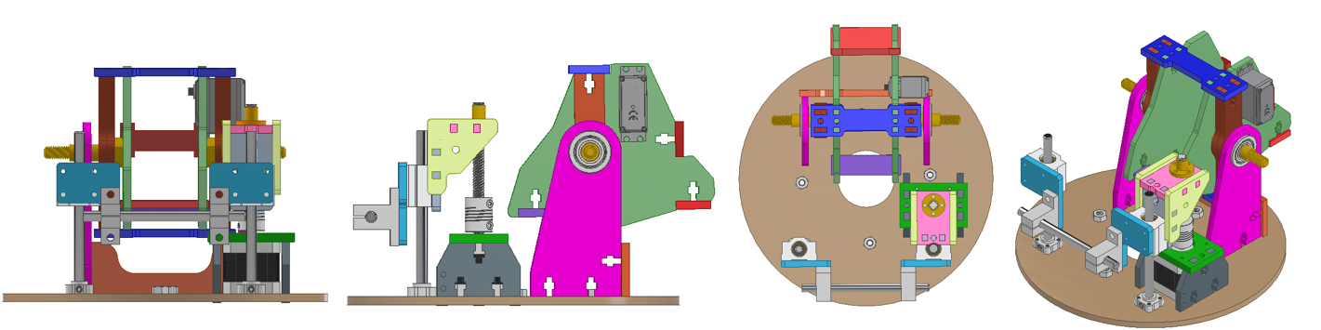

I initially considered mechanisms like worm gears, large servos, and cam-follower systems to raise and lower the Nerf Gun. However, I decided to use a leadscrew-based linear motion lifting arm system, inspired by the Z-axis mechanism on the “Graber-I3”(Ref. 1) lasercut 3D-printer. I decided on this mechanism because I had experience with a similar mechanism and related electronics on another 3D-printer inspired project, structural components could be quickly and cheaply lasercut, the system was proven to be reliable in my earlier project, and a cheap bundle package of all of the hardware components was available on Amazon.com (because of the DIY 3D-printer hobbyist community).

As further described in my project team’s Project Design Plan, I used the Captured fastener assembly method (Ref. 2), which allowed for the rapid manufacturing, assembly, and iteration of structural components. All structural components in the Turret Pitch and Rotation Subsystems 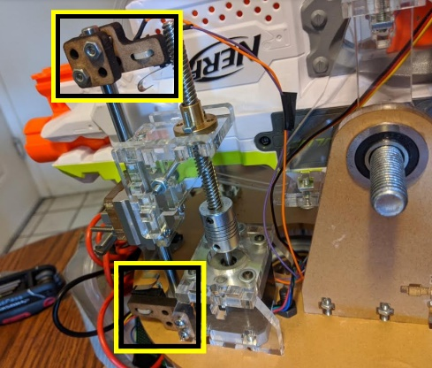and the rest of the robot were lasercut out of ¼ in Acrylic. This manufacturing and design methodology allowed us to avoid the need to spend a significant amount of time to 3d-print components, mill hardware out of aluminum, or tap a significant number of holes.

The mechanism utilizes a Nema17 Stepper motor to rotate an 8mm acme threaded rod to actuate a lead screw vertically. The extreme ends of the range of motion are constrained in software by using two end-stop switches (highlighted in yellow in the image to the right), which are mounted to a vertical guide shaft. The low-level Arduino turret command code checks if one of the switches are triggered at every step the stepper motor takes, and prevents further steps if they are triggered.

Rotation Subsystem:

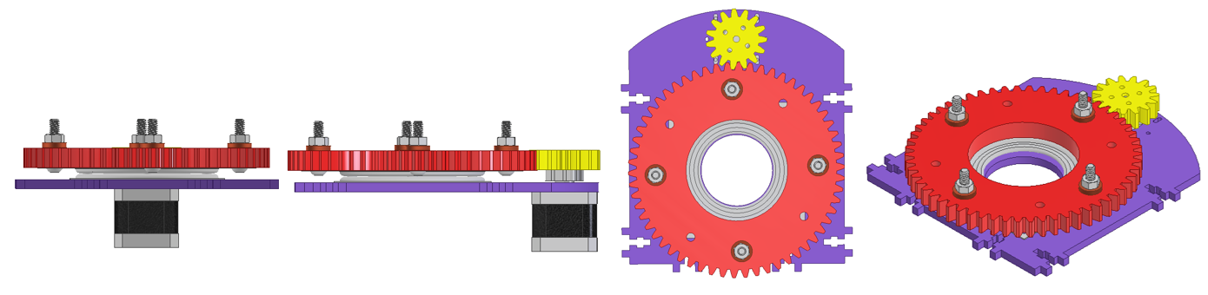

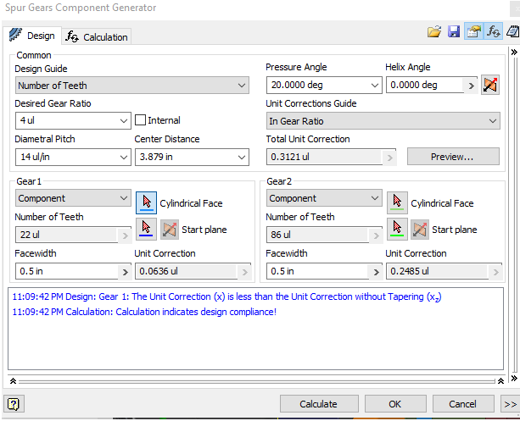Through the first half of the semester, the turret rotation subsystem was seen as a risky “nice to have” feature, as there were a number of potential problems that would not be properly evaluated until after the subsystem was manufactured. Concerns included lasercut gear tooth durability, gear tooth profiles, gear backlash- given that the “Lazy Susan” bearing below the red driven gear could horizontally shift off axis in any direction, due to loose tolerances.

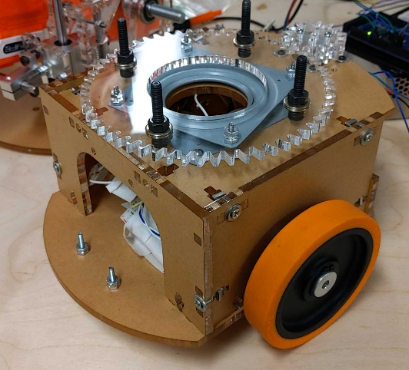The two gear profiles were generated in Autodesk Inventor’s “Spur Gear Component Generator”, with the only modified specifications from default being an approximately 4:1 gear ratio, and a tweaked diametral pitch, in order to minimize gear teeth per inch, in order to increase the tooth width. After some debate with teammates, I decided to lasercut the gear and pinion out of the same ¼ in acrylic as the rest of the robot frame, with the drive pinion gear having two stacked plates. The Nema17 stepper motor, mounted to the yellow pinion was mounted on slotted holes so that we could adjust positioning along the gear centerline. My intention was to position the stepper motor and yellow gear to keep the red gear pushed forward, to reduce backlash. After adjustment of the stepper motor position, the system has performed reliably in all tests!

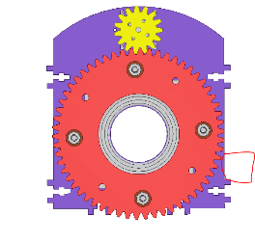While I initially researched various methods of transmitting power and signals through a slip-ring, due to slipring cost and 14+ cables that needed to pass from the Pitch subsystem to the rest of the robot, all cables were kept separate, and it was mandated throughout the team that we do not allow the turret to rotate more than 360 degrees in either direction due to potential wire damage.

In order to prevent 360+ degree rotation of the turret in any given direction, I wrote code to home the turret, and at any given time, be able to also pass along the current number of steps the turret is rotated from home position. The rotation axis is able to find home by commanding a rotation of 180 degrees counterclockwise, then 360 degrees clockwise to cover the full range of motion. At any point during this sequence, if a switch mounted to the chassis (located approx. in the red boxed area on the right) is triggered by a low hanging bolt from the pitch subsystem, the system knows to rotate a small number of steps clockwise, to reach home.

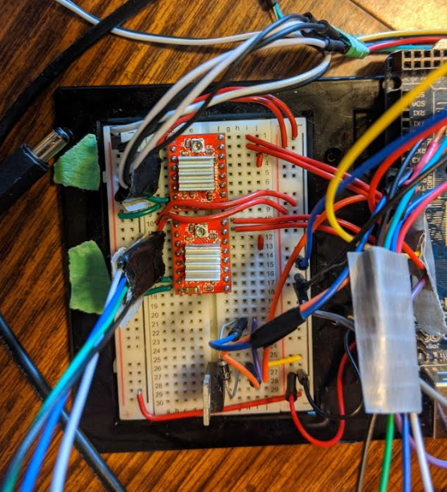Electronics:

In order to control the two stepper motors, I used two Pololu A4988 Stepper Motor Drivers that I owned from another project. Their “Step” and “direction” pins were connected to an Arduino Mega. The drivers received 5V Logic voltage from the Arduino’s power rails, and 11.1V from the LiPo battery. For the pitch endstop and rotation “home” switches, I used generic microswitches. The full circuit is diagrammed in the Final Project Report.

Conclusions:

Even though my team was not able to accomplish all of the goals of the semester project due to Covid19 impacts on project resources, I am extremely proud of what my team has been able to accomplish this semester, and my teammate’s faith in me that I might be able to successfully be able to carry out crazy additions to an already complicated project. The pitch and rotation subsystems, and Arduino code that I wrote have worked successfully in all tests of our robot. Through this project, I learned a lot in terms of team dynamics and how to successfully push for novel ideas using solid rationale. I have also strengthened my electronics, programming, and gear design skills.

**References**:

1. <https://reprap.org/wiki/Graber_i3>
2. <https://www.instructables.com/id/How-to-Build-your-Everything-Really-Really-Fast/>